NBFC IT Governance Compliance for Log360
Ensure operational resilience and NBFC IT Governance compliance with Log360.
Region: India | Type: Incident Management, Operational Resilience | Category: Compliance | Pricing: Free

Overview
The NBFC IT Governance compliance extension in Log360 helps organizations meet the RBI Master Direction on IT Governance, Risk, Controls and Assurance Practices (effective April 2024), the RBI directive mandating IT governance frameworks for NBFCs in Top, Upper, and Middle layers by providing centralized log management, continuous security monitoring, and compliance reporting. The platform supports NBFC IT Governance requirements for Board oversight, IT risk management, cybersecurity controls, vulnerability assessment, business continuity, incident response, audit logging, access management, and vendor risk.
For IT Governance Framework and Board Oversight, Log360 monitors policy changes, GPO updates, and privileged user activities to support Board-level governance reviews and demonstrate IT control oversight. To address Information Security Risk Management, the platform provides threat detection reports, security event monitoring, and risk dashboards to support annual IT risk reviews and committee oversight. The extension also supports Cybersecurity Controls and Continuous Monitoring by providing capabilities that monitors user authentication, network device logons, Active Directory activities, and MFA events to detect security threats and policy violations in real time.

Key Features
- Access Management and Privileged User Control: Log360 tracks administrative logon activity, privilege escalations, and critical system modifications across Active Directory and cloud environments to ensure strict accountability and prevent unauthorized access to sensitive financial data.
- Business Continuity and Disaster Recovery: Log360 monitors backup job outcomes, infrastructure events, and restoration activities to alert on failures and support DR testing documentation.
- Incident Response and Cyber Forensics: Log360 provides forensic log retention, threat correlation, and real-time alerting for network attacks, malware, and anomalous activities across all platforms.
- IT Audit Trails and IS Audit Support: Log360 centralizes event logs from databases, operating systems, and identity platforms to provide tamper-evident audit evidence for IS audit activities.

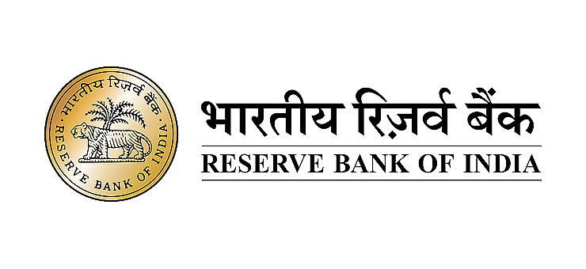
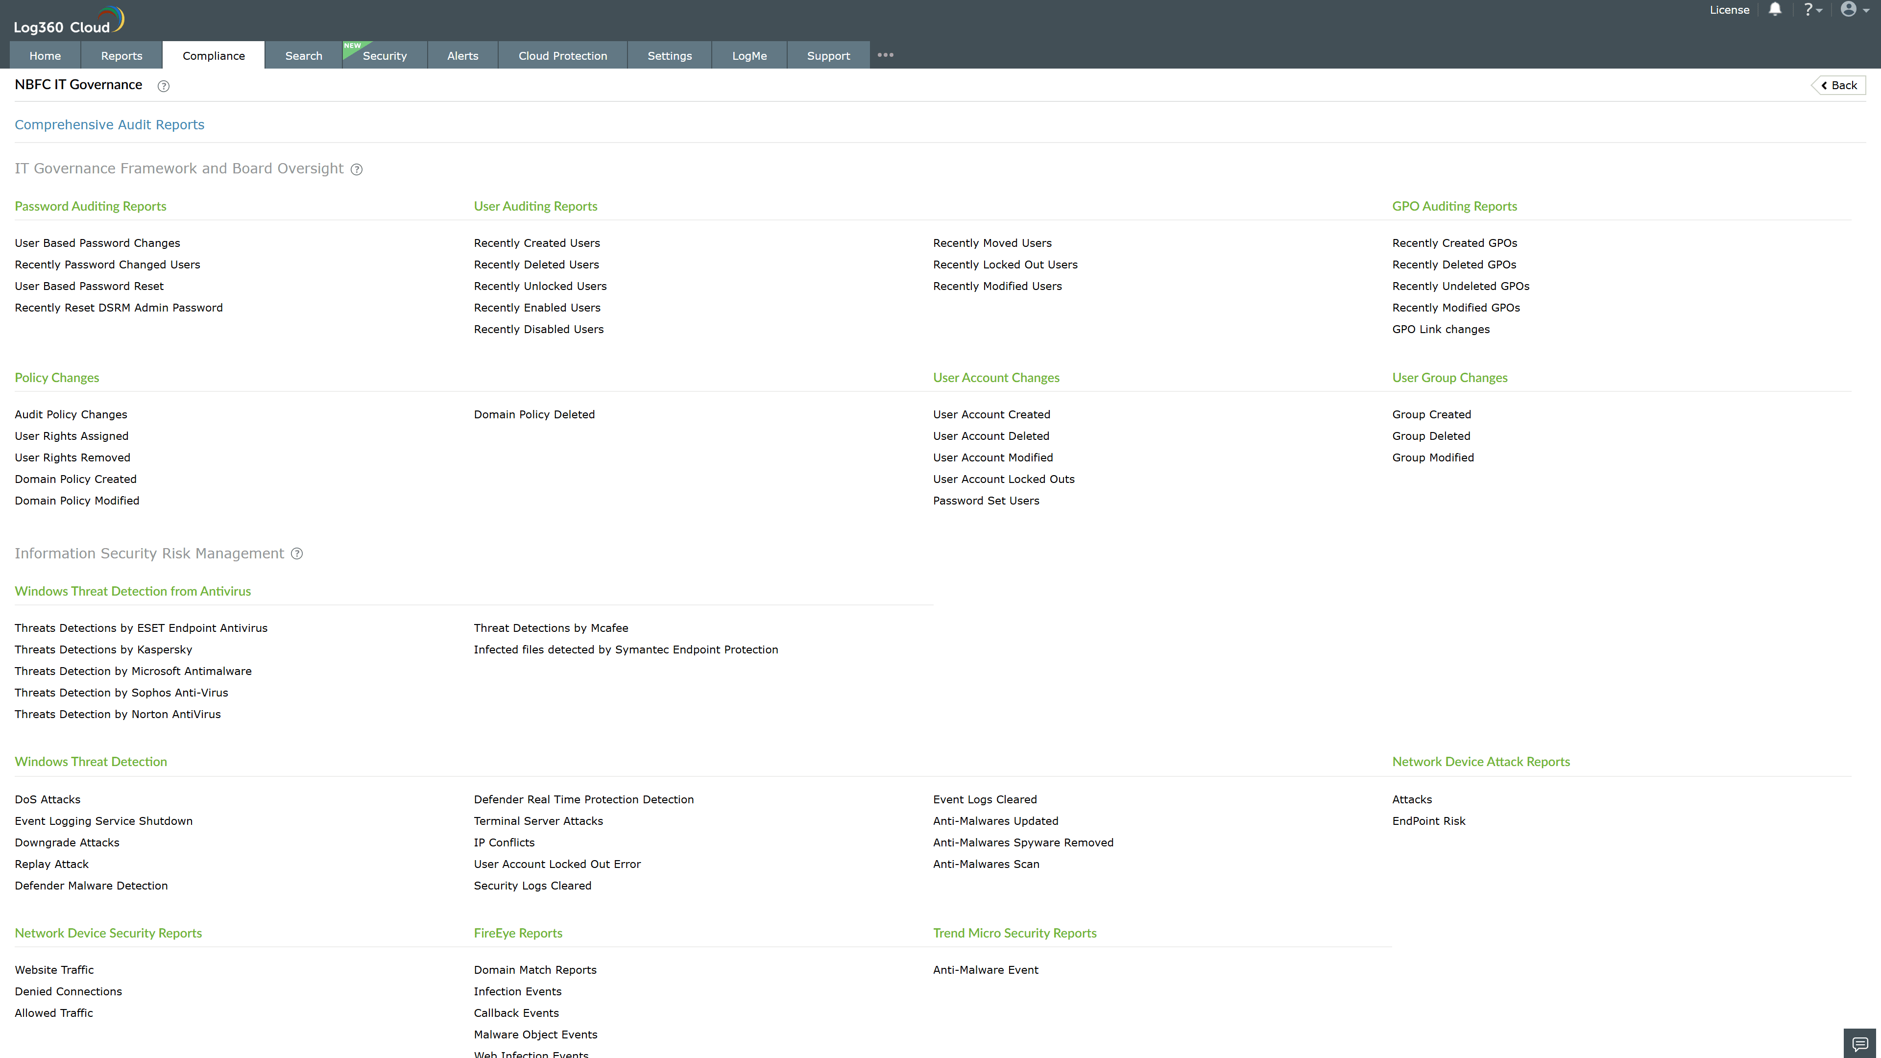
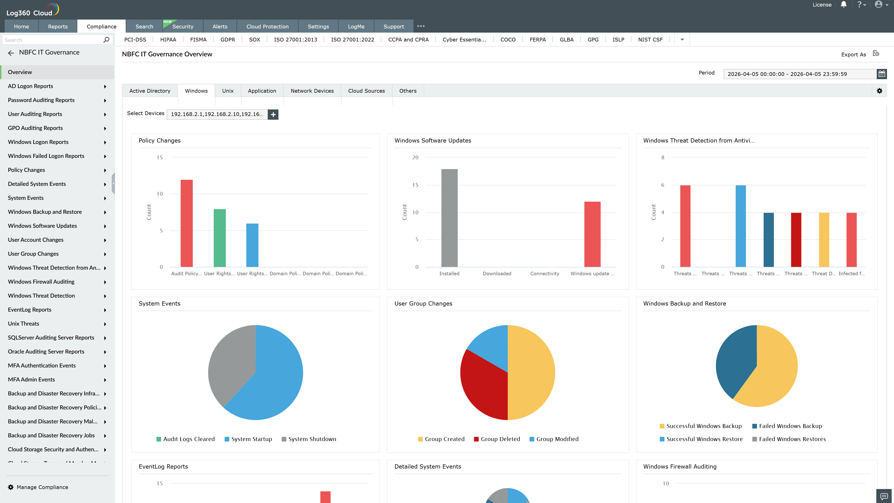
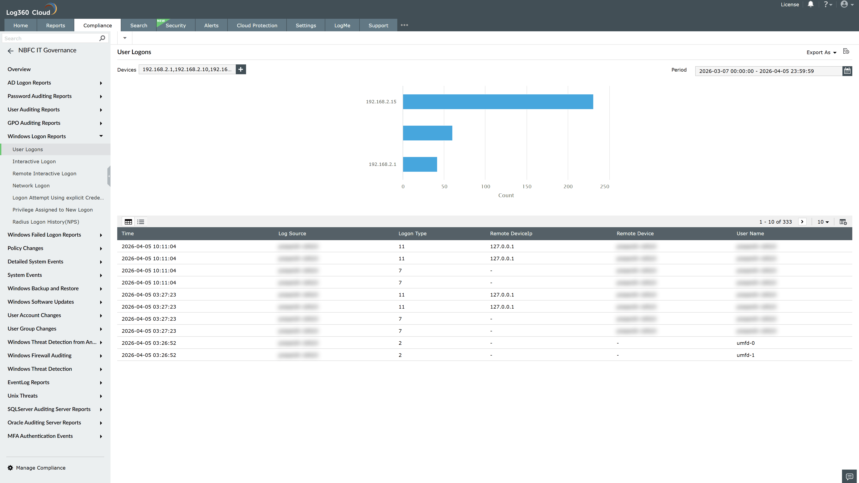
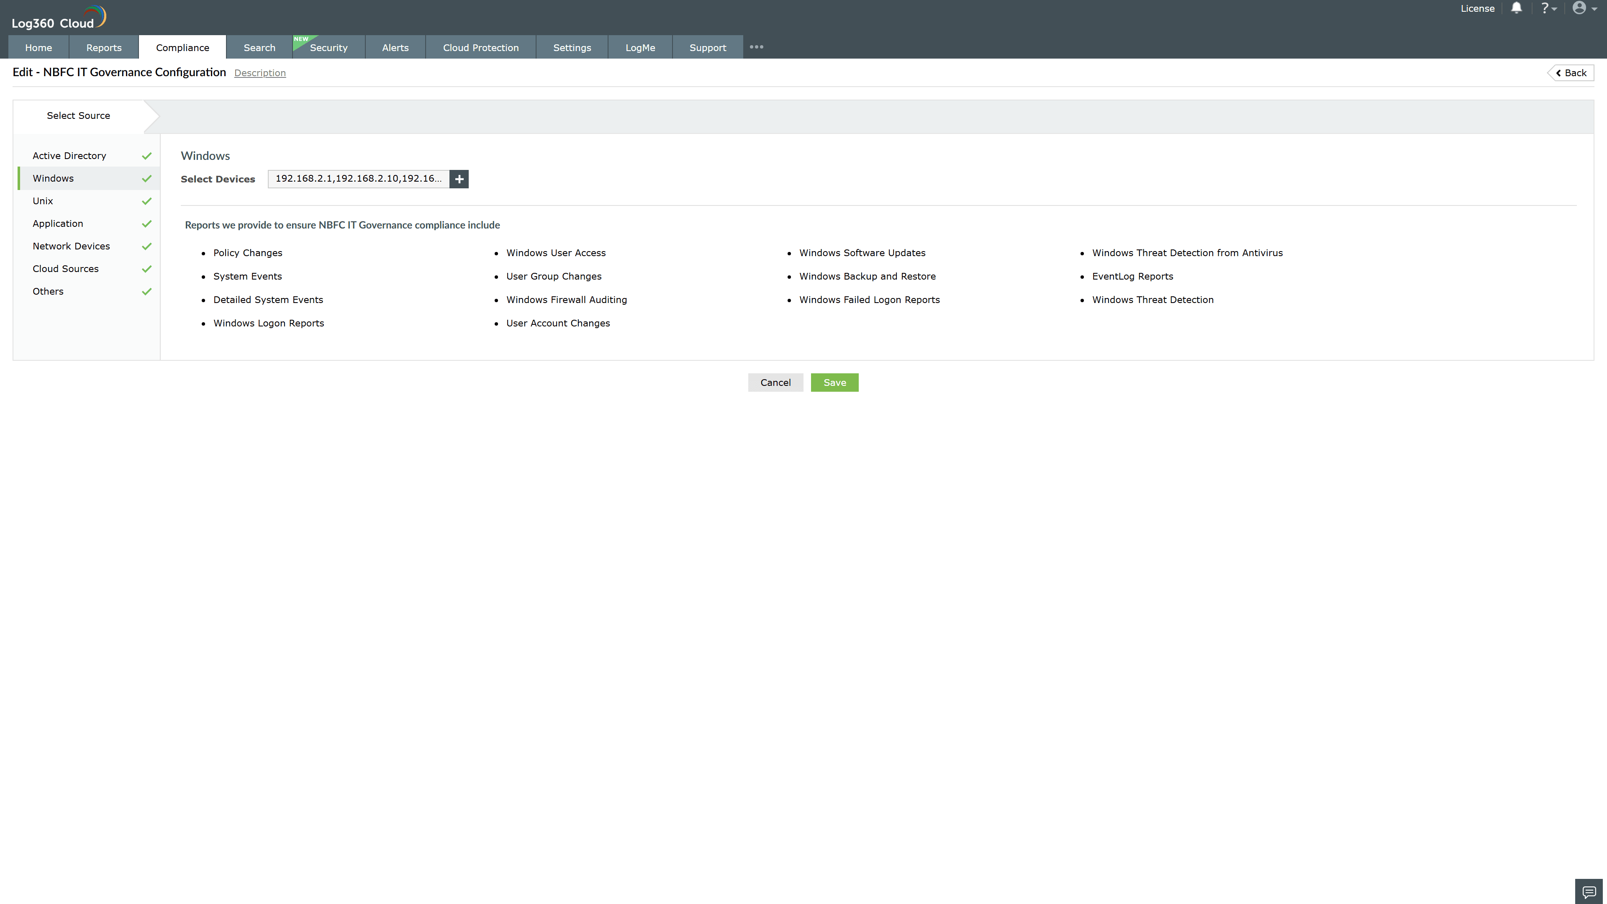
Valid Submission : Yes
Supported Editions : Free, Basic, Standard, Professional, MSSP
Help Document : https://www.manageengine.com/log-management/help/integrations/compliance-extensions.html
Help Video : Not provided
Tags : Log360, Compliance, Privacy monitoring, Data privacy, Regulatory compliance
Supported DCs : US, IN, JP, CA, AU, UK and EU
Privacy Policy:
Terms of Service:
Release Notes:
Predefined reports for the NBFC IT Governance.

